ITA06 - Machine Learning
To implement and demonstrate the FIND-S algorithm for finding the most specific hypothesis based on a given set of training data samples.
Procedure
- Define the training dataset.
- Initialize the hypothesis with the most specific values.
- Consider only positive training examples.
- Compare positive examples with the hypothesis.
- Replace differing attributes with '?'.
- Ignore negative examples.
- Display the final hypothesis.
Dataset 1: Play Tennis
Sky | AirTemp | Humidity | Wind | Water | Forecast | PlayTennis
Sunny | Warm | Normal | Strong | Warm | Same | Yes
Sunny | Warm | High | Strong | Warm | Same | Yes
Rainy | Cold | High | Strong | Warm | Change | No
Sunny | Warm | High | Strong | Cool | Same | Yes
Rainy | Warm | Normal | Weak | Warm | Same | No
Sunny | Warm | Normal | Weak | Warm | Same | Yes
Target Attribute: PlayTennis
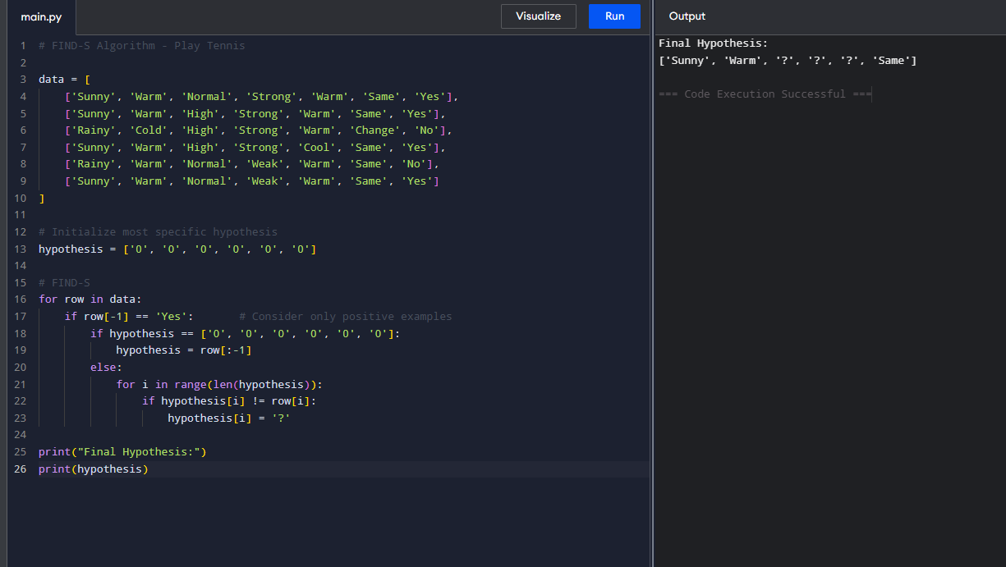
Dataset 2: Loan Approval
Income | CreditScore | Employment | Property | Age | LoanApproved
High | Good | Permanent | Yes | Young | Yes
High | Good | Permanent | No | Middle | Yes
Low | Poor | Temporary | No | Young | No
Medium | Good | Permanent | Yes | Middle | Yes
High | Average | Temporary | Yes | Old | No
High | Good | Permanent | Yes | Middle | Yes
Target Attribute: LoanApproved
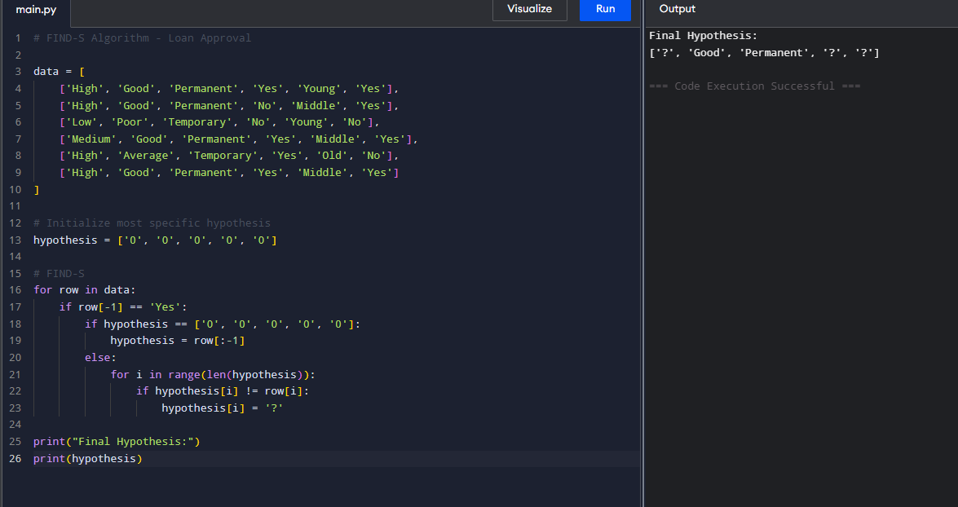
3. Dataset 3 — Student Placement
CGPA | Communication | Internship | Programming | Aptitude | Placed
High | Good | Yes | Good | High | Yes
High | Excellent | Yes | Good | High | Yes
Medium | Average | No | Average | Medium | No
High | Good | Yes | Excellent | High | Yes
Low | Poor | No | Average | Low | No
High | Good | Yes | Good | Medium | Yes
Target Attribute: Placed

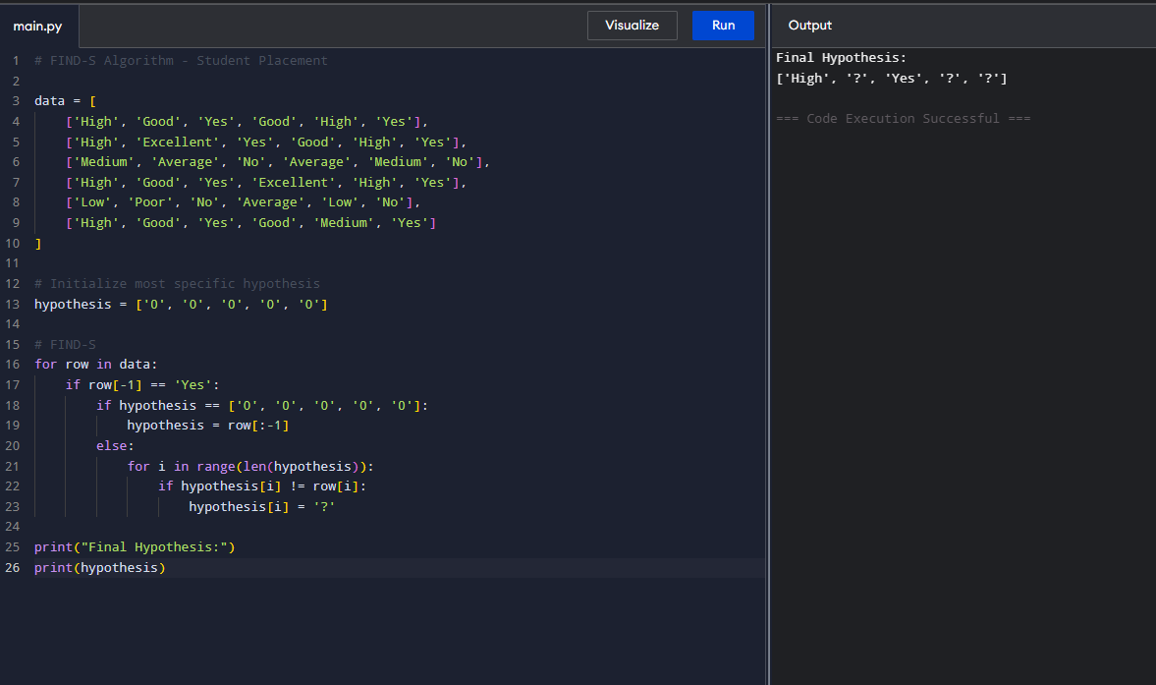

Dataset 4: Disease Diagnosis
Fever | Cough | Headache | BodyPain | Fatigue | Disease
Yes | Yes | Yes | Yes | Yes | Positive
Yes | Yes | No | Yes | Yes | Positive
No | Yes | Yes | No | No | Negative
Yes | Yes | Yes | No | Yes | Positive
No | No | Yes | Yes | No | Negative
Yes | Yes | No | No | Yes | Positive
Target Attribute: Disease

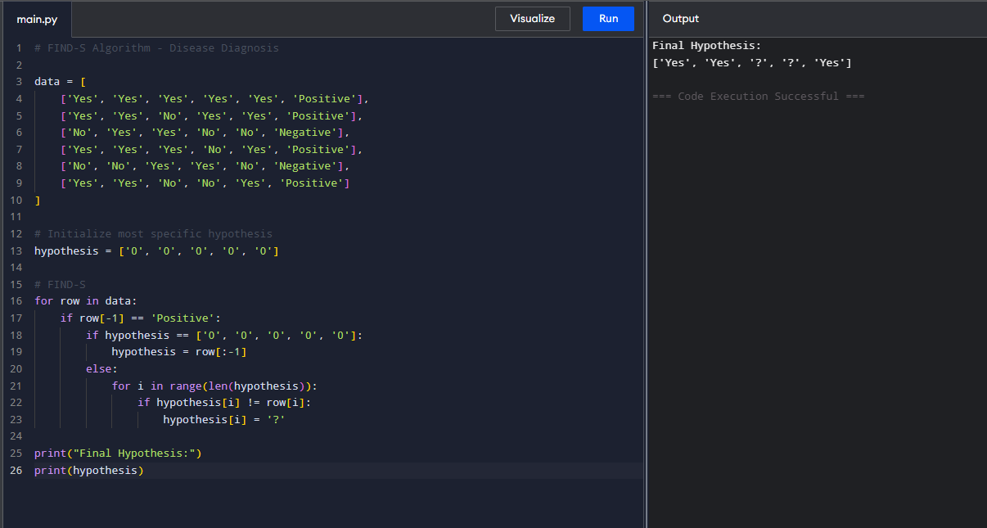
Dataset 5: Email Spam Detection
ContainsLink | ContainsOffer | UnknownSender | Attachment | ManyRecipients | Spam
Yes | Yes | Yes | No | Yes | Yes
Yes | Yes | Yes | Yes | Yes | Yes
No | No | No | No | No | No
Yes | No | Yes | No | Yes | Yes
No | Yes | No | Yes | No | No
Yes | Yes | Yes | No | No | Yes
Target Attribute: Spam
